Factors causing parent comments at youth baseball and softball games.

The many behaviors of parents at their children’s sporting events are commonly recognized as having a great effect on athlete performance and mindset. Youth sports have become increasingly time consuming and competitive, leading to rising parent interest in youth sports and engagement in the games. Sports leagues across the United States have had rising numbers of issues with parents becoming over-involved and have begun to enforce rules and regulations to prevent inappropriate parent behaviors. Parent contracts of silence have emerged in an attempt to ensure that players are able to maintain focus and energy during games. The drastic actions taken by sport administrators to deter intense parent engagement are an indicator of the extreme level of contention in the current atmosphere of youth sports, and the possible dangers therein.

Several studies have determined the types of interactions that parents have with their children during sporting events (Smoll, 1993; Evans, 1993; Randall and McKenzie 1987). These have been focused on determining whether parent/athlete interactions and parent comments are generally positive, negative, or neutral, the main targets of parent comments, and the distribution (frequency) of comments throughout the games (Wood and Abernethy 1991). Few studies have approached the factors which may cause parent engagement to be positive or negative, and few have used gender as an important focal point (baseball vs. softball). Therefore, the purpose of this study was to delve into the possible reasons for parents to make different types of comments and to determine major differences between parent engagement at baseball and softball games using both quantitative and qualitative data.

Method

Sample

The subjects of the study were the parents of children in the age group 12U who play on A level baseball and softball teams in the Frisco Baseball and Softball Association (FBSA). Approximately 137 parents were studied at four baseball games and three softball games. 3,574 comments were recorded during the research period.

Observation Method

The observations were carried out using the Parent Observation Instrument Sports Events (POISE), formulated by Kidman & McKenzie, 1996. The types of comments were adapted from those used by Kidman, McKenzie, and McKenzie (1999) and were categorized for this study as positive, negative, or neutral, with subcategories: reinforcing/motivational (+), correcting/scolding (-), contradicting/dry (-), questioning (+/-; indirect, direct, rhetorical), and extrinsic rewarding (+/-). Reinforcing/motivational (+) comments were defined as remarks conveying excitement and demonstrating positive emotions in response to a child’s actions, and efforts made to encourage the child to perform well. Correcting/scolding (-) comments included suggestions to a child that a behavior should be changed, instructions on how a child should change their behavior, displaying negative emotions in response to a child’s actions, and suggesting that a child’s actions were wrong in any way. Sarcastic, joking comments and parent advice which varies in instructions and meaning were referred to as dry/contradicting (-). Questioning comments (+/-) include the subcategories direct, indirect, and rhetorical. These comments are defined as parent musings over current actions and events and past actions and events which vary in intent and reception between positive and negative. Extrinsic rewarding comments (+/-) motivate athletes with tangible rewards and incentives for performing well. The predetermined targets for parent comments were athlete, same team parent, opposing team parent, coach, umpire, whole team, and other team.

Informal interviews with parents from several teams were conducted in order to diversify the study with varying perspectives on parent engagement. Questions were compiled beforehand, and interviews were kept brief and simple. One randomly selected parent after three randomly chosen games was interviewed, using open-ended questions, to allow full freedom in expressing their thoughts and not suggest correct answers.

In addition to informal interviews and recording parent comments, field notes were taken at each game to track basic information such as the date, time, weather conditions, general atmosphere amongst spectators, and unique occurrences which may correlate to the factors causing parent engagement. The field notes also included the updated score after each inning to track the portions of games which were spent winning or losing.

Procedures

During the observational phase of the study, one researcher attended each baseball or softball game and kept a record of the types and target of comments made by parents. The comments were recorded as tally marks on a spreadsheet, with significant or repetitive comments specifically written down in the field notes. Additionally, the child reaction and event during which the comment was made were originally intended to be recorded, but were unable to be due to the limitation of having only one researcher and the frequent inability to perceive child reactions. The coach of each team was consulted prior to the start of the games to maintain ethical standards, but the parents remained uninformed about the recording of their comments to preserve integrity.

Analysis

Parent comments were analyzed for type and target. The types and targets which were previously described were grouped together to simplify analysis. The groupings are: motivating and reinforcing, correcting and scolding, dry and contradicting, questioning, and extrinsic rewarding. The categorization of comments is shown in assorted charts following the written report.

Results

3,574 comments were recorded, 68% (2,432 comments) of which have been categorized as positive and 25% (884 comments) as negative. The remaining 7% of comments were neutral (258 comments). The average number of comments made at softball games was 409, and there were 587 comments made on average at baseball games. 68% of comments were categorized as positive at both baseball and softball games. Negative comments were much more prevalent at baseball games (27%) than they were at softball games (20%). If categories of negative comments are further broken down (correcting/scolding, dry/contradicting, questioning), the only category in which there were more comments made at softball games is questioning. Overall, the most common negative comments were correcting/scolding. An overwhelming majority of the comments were aimed at the athletes (88%) and the remaining 12% were targeted towards the whole team (7%) and other parents, coaches, and umpires (5%).

Examples of frequent comments at both baseball and softball games include, “Great job,” “Way to go [child or team name],” and “That’s okay.” Applauding or cheering after positive events was very common, as was a collective sigh or moan when players disappointed the parents. Baseball games also included a chorus of parents saying “Good eye” nearly every time a player did not swing at a pitch that was a ball. Softball parents, however, did not confirm their children’s decisions by saying “Good eye” as baseball parents did.

The intensity of comments was generally lower than expected, although several were significant. Comments that stood out as more intense include, “I will personally come out there and hit the ball for you,” “We’ve got to get to that tournament,” and “Just pretend the ball is your brother.” Additionally, one child, after striking out, made the remark, “Mom, you can’t be mad at me.” This reaction suggested that the mother had previously gotten upset about poor batting performance or had let the athlete know that she had expectations for their batting at the game.

The only instances of parents overstepping the boundaries of what is considered socially appropriate at youth games were one ejection and one father practicing batting with his daughter during the game. The ejection occurred at a baseball game and the batting practice during a softball game.

The one ejection was of a father who reacted poorly to a call made by an umpire, but took out his anger on the coach of the opposing team. The conflict stemmed from a run scored off of a third strike, which is a rule with some gray area. The bases were loaded and the batter struck out. The catcher did not have control of the ball, so the batter ran to first base, causing the runner on third to run home. All of this occurred while the fielding team was returning to their dugout, assuming the ball was out of play due to the strikeout. A father of one of the players on the fielding team yelled at the coach of the opposing team as a result of this conflict. After the father verbally assaulted the coach, the umpire ejected the father. Following this incident, the mother who was in attendance with the father confronted the umpire and attempted to convince him that he “should not be scared to speak up” and “should not be intimidated by the coaches.”

At a softball game, the starting pitcher struck out while batting. Her father decided to take matters into his own hands and asked the coaches to bench her during the next inning so that he could practice batting with her next to the field. They proceeded to practice for approximately 15 minutes before returning to the game.

Discussion

Prevalent findings which were discovered amongst the data from parent observations and informal interviews include various factors which may lead to different types of comments and behaviors by parents such as: baseball vs. softball (game differences and gender), winning vs. losing, and location of the game. Additionally, the amount of influence which parent comments have on athlete performance was lower than usually suggested.

As the number and percentages of positive and negative comments were compared, a clear pattern developed that negative comments were significantly higher in frequency at baseball games than softball games. The average number of negative comments at baseball games was 159 compared to 83 at softball games. Upon breaking down the types of negative comments into the categories correcting/scolding, dry/contradicting, and negative questioning, baseball parents were discovered to be more negative in all categories but questioning, in which softball parents made more comments. This is a unique anomaly, which may be explained by parents’ attempt not to offend or hurt their daughters. The phenomenon that is a possible cause of more negative comments at baseball games directly relates to the occurrence of more questioning at softball games. In simpler terms, parents may question their daughters more during softball games rather than directly criticizing them in order to save their feelings.

The structure of the game is a factor which is infrequently associated with determining types of parent comments. There seemed to be a definite correlation between game structure/rules and parent engagement based on data collected in the study. Baseball parents were generally more frequent with their comments, especially those which were negative. Parents of softball players were less open in sharing criticisms of their children, typically discussing flaws and mistakes in hushed voices rather than directly confronting their daughters. This is reflected in the comments recorded, as comments made at baseball games were 27% negative, compared to 20% of comments being perceived as negative at softball games.

There was no perceived difference in the tone of comments between baseball and softball games, only the number. The more conservative approach to criticism by softball parents may stem from differences in young males and females. Girls are considered to be more fragile and offendable than boys at the age of 11, which may explain the lack of public criticism by parents of softball players. Additionally, boys are socialized not to take offense and to be brave, allowing parents to be more openly critical of them.

Another difference between boys and girls is the level of interaction with their own teammates. The softball girls were observed encouraging each other more frequently than the parents cheered for them, participating in chants together, and acting closer as a team overall. The baseball boys observed cheered for each other, although not nearly as much as the parents supported them. They also did not act as close as a team and did not participate in team “rituals.” The softball teams clearly had a stronger, more developed “team culture.” Almost all of the teams had organized chants and cheers, and one team had a lucky necklace hanging in the dugout to touch. Only one baseball team engaged in a coordinated social activity during the games, which was clapping at an increasing speed as the pitcher wound up to throw the ball.

These differences may not seem significant, but by providing their own motivation and cheers, the girls softball teams reduced the number of occasions during which parent comments were being made, and ultimately this led to a reduction in negativity amongst parents. Although 12U baseball games are fifteen minutes longer than 12U softball games, the difference in the average number of comments made per game (587 vs. 409) could very likely be attributed to different treatment based on gender and socialization.

Parents who participated in informal interviews about their perspectives on engagement in games made it clear that the time when comments are the most negative and infrequent is when the team is losing, especially when they are losing towards the end of the game or by a large margin. This idea is likely, as all three interview participants suggested it, but unconfirmed by research due to the chance event that only one team out of the seven observed lost their game. The limitation of the data set prompts further research focused on the parents of teams who lose.

Based on data from the observations, the time when the most comments were made was when the team being observed was batting and the lowest frequency of comments occurred while the team being observed was fielding. There are several possible explanations for this, including the fact that athletes are less likely to hear and comprehend parent comments from the distance resulting from playing in the field, and the tendency of parents to not single out their own child with comments. One outstanding piece of data from the time spent by the players in the field is that the comments continue and even increase in level of pressure for the pitcher, and occasionally the catcher. While most of the other players are not cheered on while fielding, the amount of comments aimed at the pitcher alone are overwhelming in number. Parents may choose to support the pitcher and the catcher much more than other players due to the unique position which they are in as the only players on the team who are actively involved in every single play while fielding. Additionally, they are located the closest to the parents, and are guaranteed to hear the majority of the comments that are made.

In addition to the theory that losing impacts the number of comments made by parents, interview participants suggested that “Plano Softball is worse” and “You should see basketball parents.” The general consensus among parents who were interviewed was that Frisco baseball and softball parents are not as “crazy” or over involved as parents in other leagues and sports. The apparent lack of parents who overstep their boundaries in Frisco’s Baseball and Softball Association indicate that at least in this area, parent engagement is not as negative or disconcerting as it could be. The difference in levels and types of parent engagement in various regions could be explained by median household income/socioeconomic status, or it could be a result of cultural and social differences. Increased and intensified parent engagement in basketball compared to baseball could be due to inaccurate perception of noise due to indoor echo, the presence of more spectators allowed by more seating and being indoors, or increased time where the ball is in play.

While it is held common that parent interactions with children are influential and shape a child’s socialization, this was not found to be true relative to comments at baseball and softball games in FBSA, with the exception of instructional/correcting comments. Based on visual observations, children do not react to parent comments very often if at all. The tone of the parent comments aligned with the perceived mood of the players, but the two seemed unrelated. There were few instances in which a child would respond to a failed play or strikeout negatively, although these were perceived to be unrelated to parent comments. Several behavioral cues indicated that parent comments did not affect the children observed, including undisrupted focus and lack of visible reaction. As parents reacted verbally to most plays in the game, the athletes remained focused on their roles on the team and did not engage in response to the parents. Athlete response to parent comments was intended to be recorded in the observations, although this was found impossible due to limitations of the study. While this may not be solid evidence of parent engagement being uninfluential, it serves as possible justification for the idea that parent comments are not as important as typically believed.

The most influential experiences for children at the baseball and softball games based on visual observations were the parent ejection and the father pulling his daughter out to practice batting. These two events were the only which prompted noticeable athlete reactions. Following both incidents, the children spoke to their parents, whereas after most comments, nothing was said in response. The ejection and batting practice were both physical actions which were noticed by most of the spectators and team. Compared to normal verbal engagement in the game, these two incidents singled out the children and likely embarrassed them, while comments did not.

Yet another intriguing observation was the comments that were made by parents to their spouses or to other parents about their child’s or another child’s performance in the game. For example, softball parents share critiques of their daughters rather than vocalizing them loudly, and parents of both baseball and softball players trade excuses for why their child is not meeting their full potential during the games. Examples of excuses made to other parents include “He’s not playing well today. He was up so late last night,” “We need to work on throwing and catching more. His dad was out of town this week,” and “She has been sick all week. She still isn’t feeling well.” These types of comments appear to be made by parents to avoid feeling embarrassed by their children in front of other parents. While comments like these do not seem to be in the child or the parent’s best interest, they are better being said in private conversations than aloud or in front of the child to protect them from embarrassment.

The majority of the comments made by parents did not seem to differ by gender. There was a fairly even distribution of comments made by mothers and comments made by fathers. The only clear difference between comments made by mothers and comments made by fathers was that the vast majority of the correcting and instructional comments were made by fathers. In addition to the male association of these comments, they were typically only made by one or two spectators at each game. Rather than being said by nearly every spectator present like motivational/reinforcing comments, correcting comments were only made by the parents, specifically fathers, who were showing a great amount of interest in the game. The tendency of fathers to make correcting comments possibly stems from the common thought that men are more athletically built than women. Men are also considered to be more assertive and dominant, leading to a high likelihood that they would decide to interact with their children during the game and attempt to help them through correcting comments. The likelihood of this occurrence is higher if they have coached or played baseball or softball themselves, which may lead to a feeling of validity in stepping in to “coach” their children.

Conclusion

The influence which parents have on their children through positive and negative comments during baseball and softball games was not found to be significantly high. This may have been affected by limitations such as the inability to perceive child reactions or the occurrence of six out of seven teams winning their games. Additionally, parent responses during informal interviews suggested that games in other cities and for other sports included more parent engagement. Therefore, the collection of additional data in the future will allow this idea to be proven.

Charts

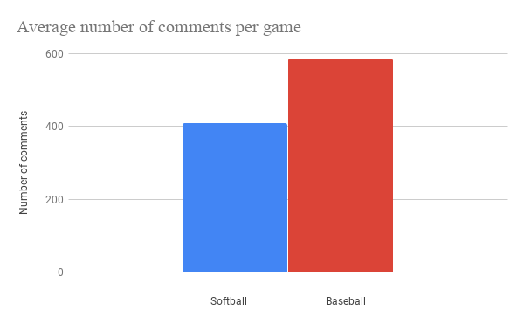

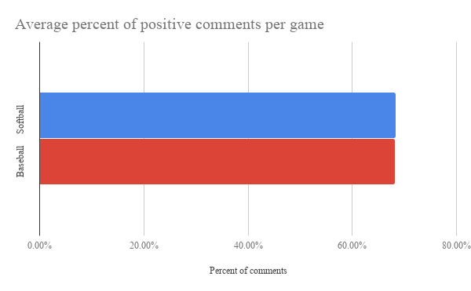
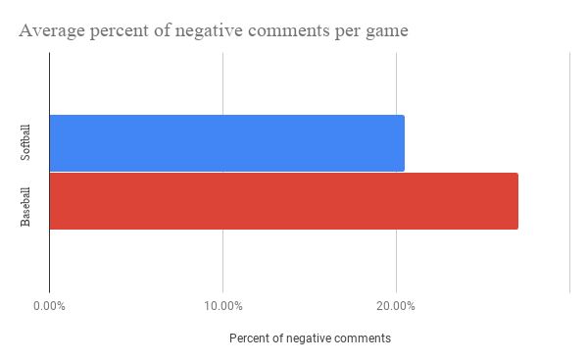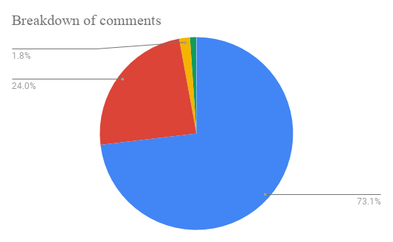
Blue: reinforcing/motivating Red: correcting/scolding Orange: dry/contradicting
Green: questioning White: extrinsic rewarding

